# Project Overview

The Duquesne Incline is a century-old cable car that offers a brilliant view of the Pittsburgh landscape and is one of the landmark tourism spots in the city. Opened on May 20, 1877, the incline was restored in the 1960s and is now a popular tourist attraction. The upper station of the incline has a museum of Pittsburgh’s history, photos, and a gift shop.

Assume you are a freelance consultant who has been hired by the Society for the Preservation of the Duquesne Heights Incline to design and build a new version of their website. Their current website is available at [http://www.duquesneincline.org](http://www.duquesneincline.org/). Its purpose is to essentially act as a tourism site that showcases the Duquesne Incline and related activities and attractions. **The new website should provide (i) any additional information about the incline you feel is necessary to be included, and (ii) a simplified but enhanced experience for visitors to navigate the website and learn about the attractions.**

# Project Requirements

The web development project is worth 10% of your final course grade. You will be evaluated on the following criteria:

* **Content** – The website includes all content requested by the client, required HTML elements, directory organization, and naming conventions (20%).
* **Contact Form and Map** – The website includes a contact form (with required fields and validation) and an embedded map (20%).
* **Graphics** – The website must be visually pleasing and include at least 7 different images

(provided to you) displayed with overall page aesthetics given due consideration (10%).

* **Layout, Navigation, and Design** – The website uses a clear/consistent navigation, and provides an improved design. You must carefully plan your layout, which we expect will be built from scratch using HTML and CSS. Do not use any frameworks, such as Bootstrap, to fulfill the layout requirements. Have a critical eye on the layout of the current website, which is not aesthetically pleasing. (15%).
* **Web Accessibility** – The website adheres to all accessibility guidelines discussed in class and included below (5%).
* **User Testing** – The project includes the required user testing materials: protocols, interview transcript and audio recordings, notes, results of your analysis, and at least 3 instances of changes made (10%).
* **User Centered Design Documentation** – The project includes all required documentation: task breakdown, user stories, design guide, wireframes (hand drawn or other low or high-fi), and user testing materials (i.e., interview questionnaire etc.) (20%).
* **Research Oriented Development** – The code is readable, organized and commented.

Outside resources and libraries are cited in the code as comments (up to 5% deduction).

**Note:** Google Chrome is the official browser of our class (i.e. your website will be graded in Google Chrome, so make sure you test in Chrome).

# User Requirements

# APPENDIX A – CLIENT CORRESPONDENCE

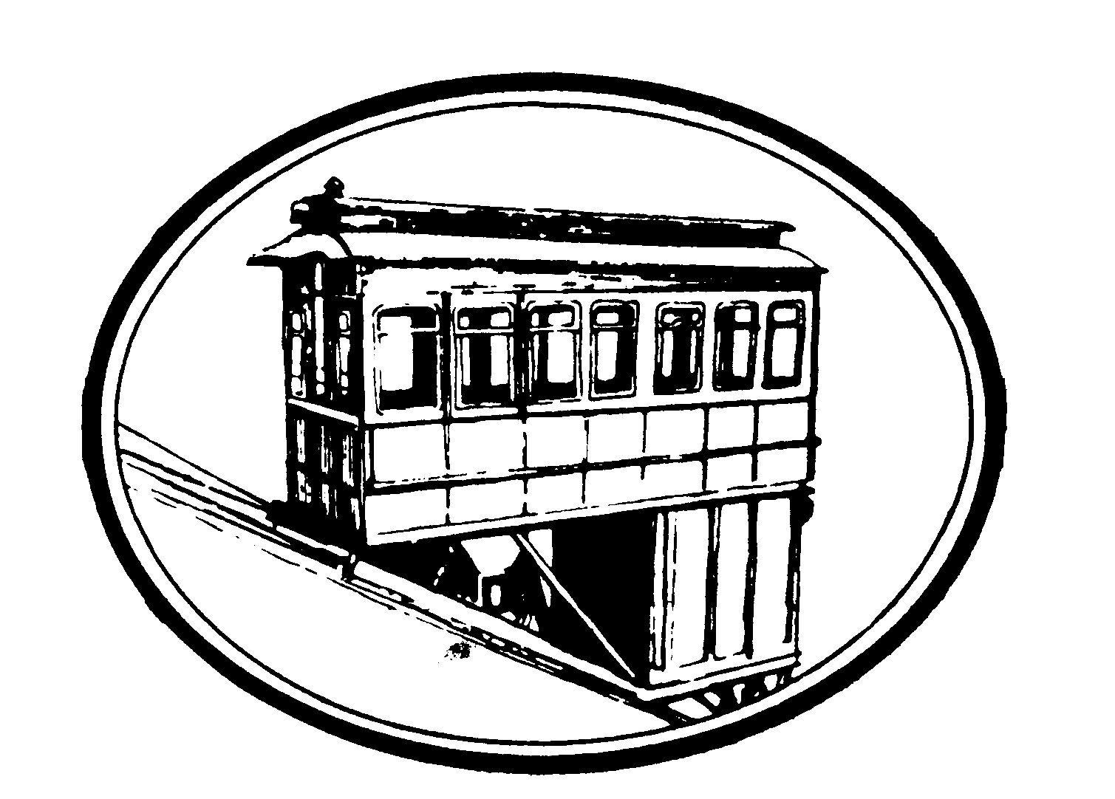

March 8, 2021

To Whom It May Concern:

My name is Patricia Miller, and I represent the Society for the Preservation of the Duquesne Heights Incline. I am very excited to have you working on our website. We have had this website since our opening in 1877, so I cannot wait to see how the tools at your fingertips can build us a more modern one.

Please focus your efforts on providing an informational and engaging guide for our [website](http://www.duquesneincline.org/index.html), while also improving its overall look and feel. While we think our menu navigation is our biggest (if not the only) strength, we are open to your suggestions in revamping the information architecture by improving how details are presented on each page.

As discussed in our Zoom call earlier this week, below are the critical components we need.

# Engaging and Clean Design

The website must remain consistent with the Duquesne Incline brand, but can depart in ways which will refresh our look to today’s web design standards**. Logo usage and writing styles must adhere to your design guide**. We require you to develop the website from scratch. In other words, do noy use existing HTML and CSS templates or frameworks. However, you may use

JavaScript libraries, such as jQuery.

In terms of the design, we require consistent, well-placed and informative navigation – something that allows visitors to easily navigate the site to learn about the Duquesne Incline. Your design must be understandable and readable with clear headings, where appropriate, **and sufficient “white space.”**

Additionally, the home page must be named index.html and located in your project’s root folder. The new website must consist of at least 3 individually linked pages conforming to an organized information architecture. The website should, at a minimum, use the **following HTML tags: page title, lists (either ordered or unordered), headings, and horizontal lines, which are appropriately styled**.

All layout and design must be controlled **with external CSS style rules (HTML table layouts are prohibited).** Any formatting (colors, backgrounds, fonts, text control, borders, etc.) must be done with external CSS style rules (HTML styling or internal/inline style rules are prohibited). **The <font> tag should NOT be used. You may create multiple stylesheets for your website, although your primary stylesheet must be named styles.css. Your stylesheets must be located in a subdirectory folder named css.**

# Important Information

Although our current website’s content is divided appropriately into each page that you can navigate into, the information on each page is not as organized as we would like it to be. Please help us present the information in an improved manner, while also expanding content as needed (see the supporting files to see what we believe is the most critical content). We hope you can improve organization for key information for new visitors, so that they can quickly navigate the material.

The following are required elements**. Improve the readability of the content and include interactions such as tabs or accordions for easy reading**. We also think rich images and videos of the view from our incline will attract new visitors. We would like to see images incorporated in the website in some interactive way, such **as lightbox galleries or slideshows**. All images must be located in a subdirectory folder named images. The website must include information about our [field](http://www.duquesneincline.org/indexc6e7.html?page=school-program) [trips](http://www.duquesneincline.org/indexc6e7.html?page=school-program) and [city](http://www.duquesneincline.org/indexbfdf.html?page=things-to-do) [tours](http://www.duquesneincline.org/indexbfdf.html?page=things-to-do) (including text content and media such as icons, images, videos, etc.) Although we do have a clear idea of how this should be presented, we are open to suggestions.

We have also found that visitors have difficulty finding our hours of operation and other relevant information. The website must include the following **contact information: address (with city, state and zip code), phone number, email address (clickable to send an email to mailto:** duq.incline@duquesneincline.org), website, and photos of the incline (appropriately sized for the page). This information must be included in an appropriately-formatted table. Our hours of operation must be included, and we also want to use Google Maps so visitors can see a map of our location on the website.

# External Links

We think it would be useful to include helpful links to relevant information, such as online articles about the Duquesne Incline or our social media pages. The website must include at least 3 links to external websites (you can select the websites). One link must be a graphic/image, but the rest can be text or graphics/images. **These links must open in new tabs/windows and change colors once they have already been clicked.**

# Mailing List

We also want to provide a contact form where visitors can submit their contact information to join our mailing list. The following are the fields to be included in the contact form.

1. Name (required field)
2. Zip code (optional field, but if it is filled in, it must be a five-digit code)
3. Email address (required field and conforming to an email address format)
4. Check box to indicate if they would like to subscribe to the Duquesne Incline’s newsletter

(optional field).

1. All fields should be set to appropriate minimum and maximum sizes.
2. Submission button.

Since we conduct most of our correspondence via email, the form can be submitted to us via email to duq.incline@duquesneincline.org.

# Web Accessibility

To accommodate the diverse needs of all users of the website, it is necessary to implement web accessibility features (refer to <https://www.w3schools.com/html/html_accessibility.asp> for guidance). The following are mandatory checks for all pages on your site:

1. **Tags:** Ensure each page has an appropriate and meaningful <title> attribute and the language of the page is clearly indicated. Ensure all headings are marked up with an appropriate heading tag h1-h6 and are meaningful. Ensure the use of link title attributes.
2. **Validation:** Navigate to <https://validator.w3.org/>. Click on “Validate by Direct Input” and check your code for each page: index.html, page2.html, page3.html, etc. Make any necessary corrections.
3. **Images:** Ensure all images have a meaningful description in the alt attribute. No images of text should be included.
4. **Fonts and color:** Most fonts must be sans-serif fonts, which are easily readable on screens (e.g. Arial, Century Gothic Regular, Helvetica, Verdana, etc.). Use of serif fonts, such as Times New Roman, is acceptable for short headings, especially if included for aesthetics. Use a maximum of 2-3 different fonts. Please consider color contrast as well.
5. **Interactions:** Do not include flashing elements (no content flashes more than 3 times).
6. **Accessibility:** All elements on the page should be [keyboard](https://webaim.org/techniques/keyboard/) [accessible](https://webaim.org/techniques/keyboard/). Check if all elements on a page can be tabbed through in a meaningful sequence by clicking on the

URL box and pressing the Tab key until you reach the end of the page.

1. **Language:** We expect some original content in the site (e.g. headings and labels). Use clear language that is easy to understand. For example:
   1. Keep sentences as short as possible.
   2. Avoid dashes. Instead of writing 1-3, write 1 to 3.
   3. Avoid abbreviations. Instead of writing Feb, write February.
   4. Avoid slang words.

# User Testing

In order to gauge the effectiveness of your work, we would like to test our website to see if our users can navigate effectively and efficiently through the pages. To do so, please prepare written protocol for how you will be interviewing users and questions to ask your interviewees. Then, interview **TWO** users (or perceived users) to navigate through **FIVE** of your user stories. The interview should last between 3-5 minutes. Feel free to do this over Zoom. Have someone record the interview (audio only—or just hit record if on Zoom, see below), while you ask the user to talk out loud (say what they are thinking) as they navigate through the website. Take notes on the process, marking times when the user is uncertain or hesitant.

Please submit URL links to the interview audio clip (post the audio file to an online platform, such as Google Drive or YouTube—do not submit the video with your project, as the file size is too large), notes for the interview, and a brief paragraph explaining what your results were and what you changed in your design (at least 3 changes) to reflect your user testing results, and what you would change if you had more time.

**Note:** If you are recording via Zoom, you can submit the audio only file that Zoom generates after the meeting. If you are recording to the cloud, you can find recordings on [cmu.zoom.us](https://cmu.zoom.us/). If you are recording to your local hard drive, you can find where your recordings are stored in

Zoom preferences -> Recording. Again, make sure you upload the file to Google Drive or

YouTube and submit it in the form of a URL (with correct permissions).

# User Centered Design Documentation

We also plan to hire a full time web developer to support the website once deployed.

Therefore, it is imperative that you provide your documentation:

1. The task breakdown for the project (including all tasks and due dates, planned and actual). You must use our template (in the supporting files).
2. A list of at least 7 user stories organized by priority. You must use our template (in the supporting files).
3. **A design guide that defines your approach (color palette, font choice, etc.). The design guide should also include a half-page write-up of how your design is intended for visitors navigating the site for the first time. Also include a half-page write-up that explains the information architecture approach, and provides a site map.**
4. **Wireframes. Include a photo of a hand-drawn** wireframe (or other low or hi-fi prototype) for each page in your website for desktop views only.
5. User testing materials, including protocols, notes, **links** to the audio recording, analysis and recommendations (as described above).

Please do not hesitate to contact me with questions or concerns. I look forward to receiving your final deliverable.

Sincerely,

Patricia Miller

Duquesne Incline Pittsburgh

# APPENDIX B – POPULAR WIREFRAMING TOOLS (FOR REFERENCE)

Adobe XD: <https://www.adobe.com/products/xd.html>

Figma: <https://www.figma.com/>

Sketch: <https://www.sketch.com/>

Balsamiq: <https://balsamiq.com/>

# Deliverable Requirements

**Instructions:**

1. Please submit all of your work (except any videos) in one zipped folder, appropriately named as **webdevproject-lastname.zip** (e.g., webdevproject-quesenberry.zip). This folder should contain all of your web development code (HTML files in the root folder named **webdevproject-lastname**, CSS files in a folder named css, JavaScript files in a folder named js, images and media in a folder named images, and documentation (see Appendix A) in a folder named documentation). All HTML, CSS and JavaScript files should be organized, clear, and commented.
2. Test your website after submission by downloading it to a different machine and opening it with the Chrome browser. This will be particularly helpful if you maintain multiple versions of the website during development and upload the wrong version.
3. A penalty of 5% will be applied if the HTML files use absolute addresses, excluding the external links (e.g., unzipping the project to another computer folder MUST yield a functional website in the browser).